A Study on Consumers Satisfaction towards Samsung Mobile Phone in Erode District

S. Kalaiselvi and P. Karthika

Commerce, Vellalar College for Women (Autonomous),
Erode – 638012, Tamil Nadu, India; cutekalai2003@gmail.com. pkarthika.mcom@gmail.com

Abstract
The objective of this research is to evaluate the consumers’ satisfaction towards Samsung mobile phone in Erode district. This study exhibits the relationship between demographic variables and study related factors. This research is based on primary data collected through questionnaire. The size of sample is 150 selected on convenient sampling method. The statistical tools like Simple Percentage Analysis, Chi-square test and Weighted Average Ranking Technique are employed for analyzing the data. The results of the study show that most of the respondents have faced the problem of quick battery drain. It was also found that the factors namely Gender, Marital status, Educational qualification, Occupational status and Place of residence have no significant association with the level of satisfaction of the respondents.
Keywords: Consumers, Samsung Mobile and Satisfaction

1. Introduction

In the world of today, mobile making companies are mushrooming. Every month the companies are launching new models to cater to needs of the society. Now-a-days, consumers are more aware about prices and latest facilities available in assorted company’s mobile phones. In day-to-day existence, communication plays a key position and reached peak in the telecommunication field. The customer’s needs and wants are changing every day. The companies are introducing new services to meet the customer requirements and effective utilization. The main motto of every company is to satisfy the customers because they are asset to the companies. Customer centricity is considered as an indispensable element of every successful business. This is the reason why all companies focus on continuously improving customer satisfaction. Satisfying the customers is the most important indicator of purchase intention and customer loyalty. It helps the companies to identify the business growth and revenue. In telecommunication field, Samsung plays a pivotal role. This study is an attempt made to identify the level of consumer satisfaction towards usage of Samsung mobile phone in Erode district.

2. Review of Literature
Samaan Al-Msallam¹ illustrated that customer satisfaction had appreciably influenced the customer loyalty. It was in turn influenced by brand image and price fairness. Customer perception towards brand image and price fairness contributed to improve satisfaction level. Dharmalingam and Palanisamy² found that consumers had positive approach on green products. The higher level of income and education had influenced the people to obtain more knowledge on environmental issues and green products. It revealed that the level of education had an impact on the selection of the green house hold products by the users. Vanitha and Subramanian³ indicated that there was a direct relationship between brand awareness and customer engagement. The awareness of the people about the brand continued till they faced bad experience. Youghui Rao et al.⁴ inferred that consumers were satisfied in shopping from direct e-store as they would get different experiences.

3. Statement of the Problem

Brand awareness is the foundation of all the marketing efforts. Marketers know that they need to build brand awareness. Brand awareness is important because it is the very first step in the marketing funnel and a vital foundation to eventually acquire customers. It increases market share and sales, improve brand perception, acquire audience data, increase customer’s trust, help to reach out target audience and make marketing more easier. A study on brand awareness increases the chance of converting people into customers. In recent years, Samsung mobile phones market declared its new business strategy focusing on consumer and marketing. There are about 150 new models of mobile phone launched everyday to attract the modern consumers in such a way that their expectations are met.

Consumer satisfaction will vary from person to person and from product to product. The level of behavior may also vary depending on the demographic factors of the consumers. Samsung mobile phone products are mostly liked by the consumers. But the level of satisfaction will vary from one person to other. Against these backgrounds, the study is an attempt to analyze the consumers’ satisfaction towards the usage of Samsung mobile phone product and to find answers for the following questions.
    - Whether the consumers are satisfied with the usage of Samsung mobile phone? and
    - What are the problems faced by the consumers while using Samsung mobile phone?

4. Objectives of the Study
- To identify the significance of association of various socio-economic variables with the level of satisfaction of consumers in using Samsung mobile phone.
- To analyze the barriers faced by the consumers while buying Samsung mobile phones.

5. Methodology
The study has been carried out with the consumers at Erode District. The field survey has been carried out from the month of December 2021 to April 2022 to collect primary data. The Convenient Sampling Technique has been adopted to collect the pertinent data from the respondents.150 respondents are taken as sample for this study.

6. Hypothesis
H₀: There is no significant association between socio-economic variables and the level of satisfaction of the respondents towards Samsung mobile phone.
7. Analysis and Discussion
7.1 Socio-economic Background of the Respondents

The various demographic and study related variables namely age, gender, marital status, educational qualification, occupational status, monthly family income, nature of family, size of the family, place of residence, period of usage, source of information, sales and service experience, place of purchase, opinion on price of phone, preference for storage capacity, frequency of purchase, opinion on price of Samsung mobile in Indian market, opinion about information on Samsung mobile phone, opinion about design and color, attributes in buying decisions, attitude towards phone, opinion towards perceived features, payment options, reasons for brand switching and opinion on difference in offers and services are examined with Simple Percentage Analysis. The details are shown in Table 1.

Table 1. Socio-economic background of the respondents
Factors | No. of Respondents | Percentage (%)
Age  Upto 20 years  21-30 years  31- 40 years  41- 50 years  Above 50 years  Gender  Male  Female  Marital Status  Married  Unmarried  Educational Qualification  School level  Graduate  Professionals  Others  Occupational Status  Student  Business  Professional  Others  Monthly Family Income  Upto Rs.20,000  Rs.20,001 - Rs.30,000  Rs.30,001 - Rs.40,000  Rs.40,001 - Rs.50,000  Above Rs.50,000  Nature of Family  Joint Family  Nuclear Family  Size of the Family  Upto 3 Members  4 – 5 Members  Above 5 Members  Place of Residence  Urban  Semi-urban  Rural  Period of Usage  Less than 2 years  2 – 3 years  3 – 5 years  More than 5 years  Source of Information  Advertisement  Newspaper  Internet  Friends  Others  Sales and Service Experience  Excellent  Good  Average  Semi-Average  Below Average  Place of Purchase  Online  Mobile shop  Hypermarket/Malls  Does not matter(Any place)  Opinion on Price of Phone  Highly Expensive  Expensive  Moderate  Low  Very Low  Preference for Storage Capacity  16 GB  32 GB  64 GB  128 GB  Others  Frequency of Purchase  While phone is broken  Special Occasion  New launch  Others  Opinion on Price of Samsung Mobile in Indian Market  Reasonable  Expensive  Moderate  Economical  Cheap  Opinion about Information on Samsung Mobile Phone  Excellent  Good  Average  Poor  Very poor  Opinion about Design and Color  Good  Very Good  Improvement Needed  Poor  Very poor  Attributes in Buying Decisions  Popularity  Phone quality  Price  Packaging  Others  Attitude towards Phone  Represent good value for money  Better than conventional brand  Price is affordable  Better distribution  Opinion towards Perceived Features  More fashionable  More reliable  Special features  Recognized brand  Familiar  Payment Options  Cash on delivery  Credit card  Debit card  Net banking  Others  Reasons for Brand Switching  Boring  New version  Theft  Ruined  Others  Opinion on Difference in Offers and Service  Yes  No | 39  58  31  13  9  81  69  93  57  41  68  19  22  43  36  20  51  37  24  10  23  56  91  59  46  76  28  43  55  52  46  69  19  16  42  29  32  37  10  52  27  30  23  18  43  61  26  20  19  57  47  16  11  16  25  44  52  13  35  30  65  20  34  35  40  23  18  55  40  20  10  25  43  35  30  27  15  49  35  26  25  15  47  51  25  27  40  19  30  35  26  54  26  25  30  15  18  40  33  49  10  81  69 | 26.00  38.67  20.67  8.66  6.00  54.00  46.00  62.00  38.00  27.33  45.33  12.67  14.67  28.67  24.00  13.33  34.00  24.67  16.00  6.67  15.33  37.33  60.67  39.33  30.67  50.66  18.67  28.66  36.67  34.67  30.66  46.00  12.67  10.67  28.00  19.33  21.33  24.67  6.67  34.67  18.00  20.00  15.33  12.00  28.67  40.67  17.33  13.33  12.67  38.00  31.33  10.67  7.33  10.67  16.67  29.33  34.67  8.67  23.33  20.00  43.00  13.33  22.67  23.33  26.67  15.33  12.00  36.67  26.67  13.33  6.67  16.67  28.67  23.33  20.00  18.00  10.00  32.67  23.33  7.33  16.67  10.00  31.33  34.00  16.67  18.00  26.67  12.67  20.00  23.33  17.33  36.00  17.33  16.67  20.00  10.00  12.00  26.67  22.00  32.67  6.67  54.00  46.00
Source: Computed
Table 1 shows that a majority of 38.67% of the respondents belong of the age group of 21-30 years, 54% of them are male, 62% are married, 45.33% are graduates, 34% of them belong to occupational status of other categories, 37.33% are earning a monthly family income of above Rs.50, 000, 60.67% belong to the category of joint family, 50.66% of them have 4-5 members in their family, 36.67% are residing in semi-urban area, 46% of the respondent’s usage period of Samsung mobile phone is 2-3 years, 28% of the respondent’s source of information about Samsung mobile phone is through advertisement, 34.67% of the respondents opine sales and service as excellent, 40.67% of the respondents get the Samsung mobile phone from mobile shop, 38% of the respondents’ opinion on price of the phone as moderate, 34.67% of the respondents prefer 128GB, 43.34% of the respondents buy Samsung mobile phone at the time of new mobile launch, 26.67% of the respondents rate the price of Samsung mobile phone as expensive, 36.67% of the respondent’s opinion about information of Samsung mobile phone is excellent, 28.67% of the respondent’s opinion about design and color of Samsung mobile phone is that it is good, 32.67% of the respondents are influenced by popularity, 34% of the respondent’s attitude towards Samsung mobile phones is that it is better than conventional brand, 26.67% of the respondent’s opinion towards perceived features of the Samsung mobile phone is that it is more fashionable, 36% of the respondents prefer cash on delivery for payment options, 32.67% of the respondent’s reasons for brand switching is due to ruin of mobile phone, 54% of the respondents feel the difference in offers and service of Samsung mobile phone when compared to other brands.

7.2 Measuring Customer Satisfaction through Chi-Square Analysis
In order to ascertain the significant association between the various socio-economic variables (gender, marital status, educational qualification, occupational status and place of residence) and the level of satisfaction towards the purchase of Samsung mobile phone, a null hypothesis is framed and is tested with chi square test at 5% level of significance. The findings are exhibited in Table 2.

Table 2. Socio-economic variables and level of satisfaction

Variables | Degrees of freedom | Calculated value | Table value | Significant / Not significant
Gender | 2 | 0.057 | 5.99 | Not Significant
Marital Status | 2 | 0.774 | 5.99 | Not Significant
Educational Qualification | 6 | 6.229 | 12.59 | Not Significant
Occupational Status | 6 | 2.991 | 12.59 | Not Significant
Place of Residence | 4 | 1.690 | 9.49 | Not Significant
Source: Computed
Table 2 exhibits that there is no significant association between all the selected socio-economic variables of the respondents (gender, marital status, educational qualification, occupation and place of residence) and level of satisfaction towards the purchase of Samsung mobile phone.

7.3 Problems faced by the Respondents towards Purchase of Samsung Mobile Phone
In the purchase of Samsung mobile phone, six problems are identified namely phone over heating, having trouble in connecting with wifi, audio and micro phone problem, frozen screen, camera and battery dies quickly. These are examined by applying weighted average ranking technique. The following Table 3 shows the ranking of problems faced by the respondents in the purchase of Samsung mobile phone.

Table 3. Problems faced by the Respondents
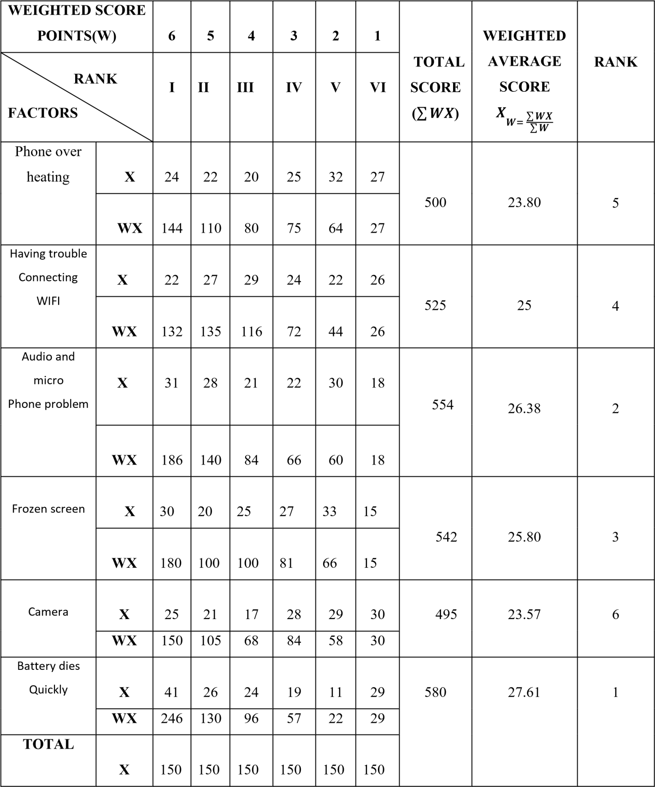
Source: Computed

The Table 3 shows that out of various problems, battery dies quickly is given first rank with the weighted average score of 27.61 and the second rank is given to audio and micro phone problem with the score of 26.38. It is followed by frozen screen whose weighted average score is 25.80, having trouble connecting wifi with the score of 25, phone over heating with the weighted average score of 23.80 and camera with the score of 23.57.
8. Suggestions

The constructive suggestions offered based on the findings of the study are as follows:

- The company may give more offers and free samples to the consumers, so that it can attract more number of consumers.
- Price should be reduced to some extent to facilitate all classes of people to purchase the Samsung mobile phone.
- The company can make better packing of products to fulfil the customer’s needs. The packaging can be better.
- Variety of models should be introduced to cover the young generation.
- The company can improve the availability of products in retail shop.
9. Conclusion

The present era is tech savvy which is rapidly changing. It also has its impact on taste and preference of the consumers. In today’s world of rapidly changing technology, consumers’ taste and preference are also characterized by fast change. A satisfied customer will soon change to other product but a loyal customer will not do like that. The firm has to be constantly innovative and understand the consumer’s needs and wants. Customers have to be educated about the productive usage of Samsung mobile phone. It will help to tap the potential of the market. Moreover, the Samsung company has to change its strategy in advertising to capture the market. The suggestions provided will help the Samsung mobile phone company to meet the expectations of its target customers and thereby creating a place for it in the market.

10. References
1. Al-Msallam S. Customer satisfaction and brand loyalty in the hotel industry. European Scientific Journal. 2015; 1:232–51.
2. Dharmalingam R, Palanisamy V. Consumers' perception towards green products with reference to Vellore District. International Journal of Engineering and Advanced Technology. 2019; 9(1): 5340–4. https://doi.org/10.35940/ijeat.A2970.109119
3. Vanitha P, Subramanian S. A study on brand awareness and customer engagement. Indian Journal of Public Health Research and Development. 2020; 11(3):258–62.
4. Rao Y, Saleem A, Saeed W, UI Haq J. Online consumer satisfaction during COVID-19: Perspective of a Developing Country. Frontiers in Psychology. 2021; 12:1–12. PMid: 34659069 PMCid: PMC8517174. https://doi.org/10.3389/fpsyg.2021.751854

